SQL UNION & UNION ALL EXERCISE
Student No: 2805001764
Name: Jafter Selelo
SQL Environment used - Databricks

QUESTION 1:
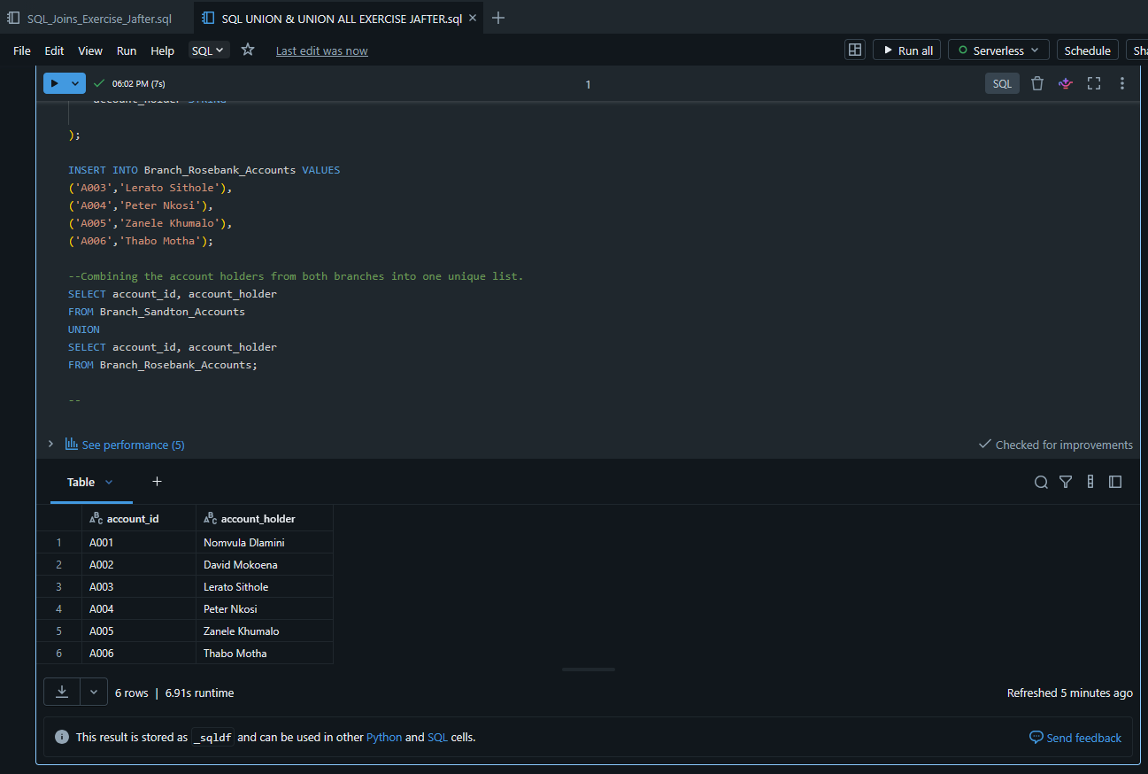

QUESTION 2:
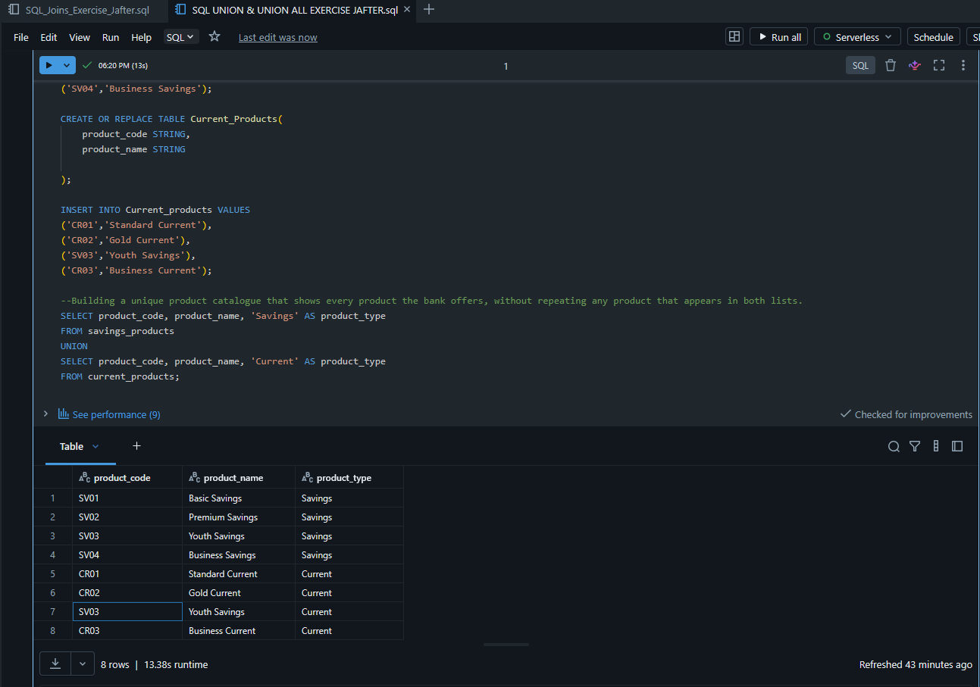
QUESTION 3:
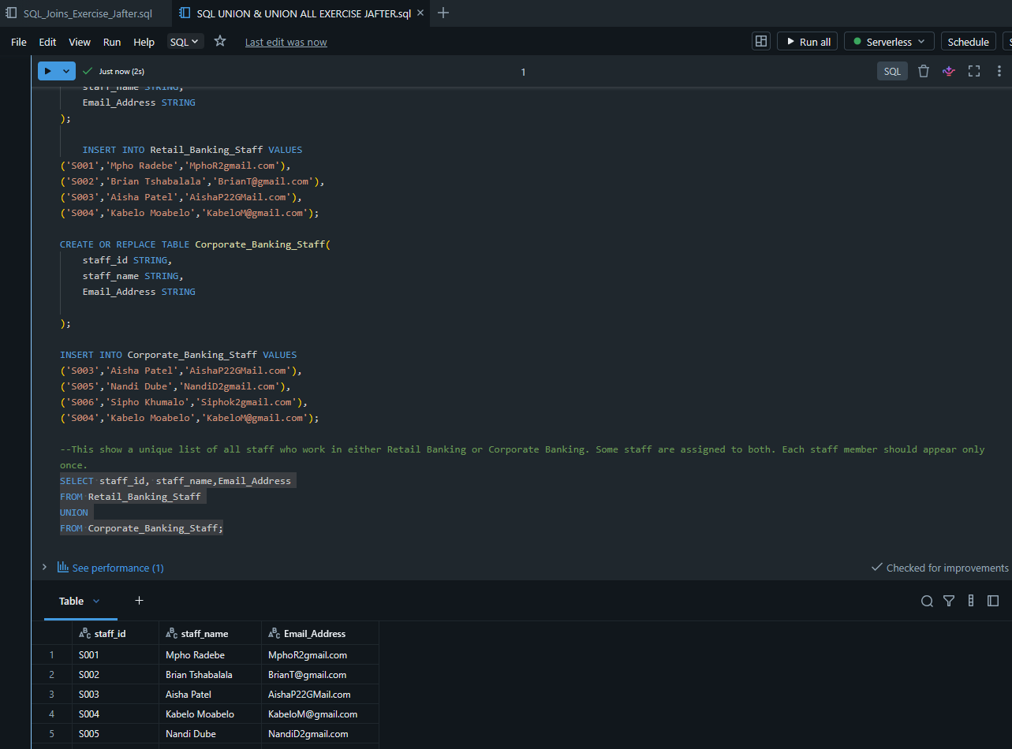

QUESTION 4:

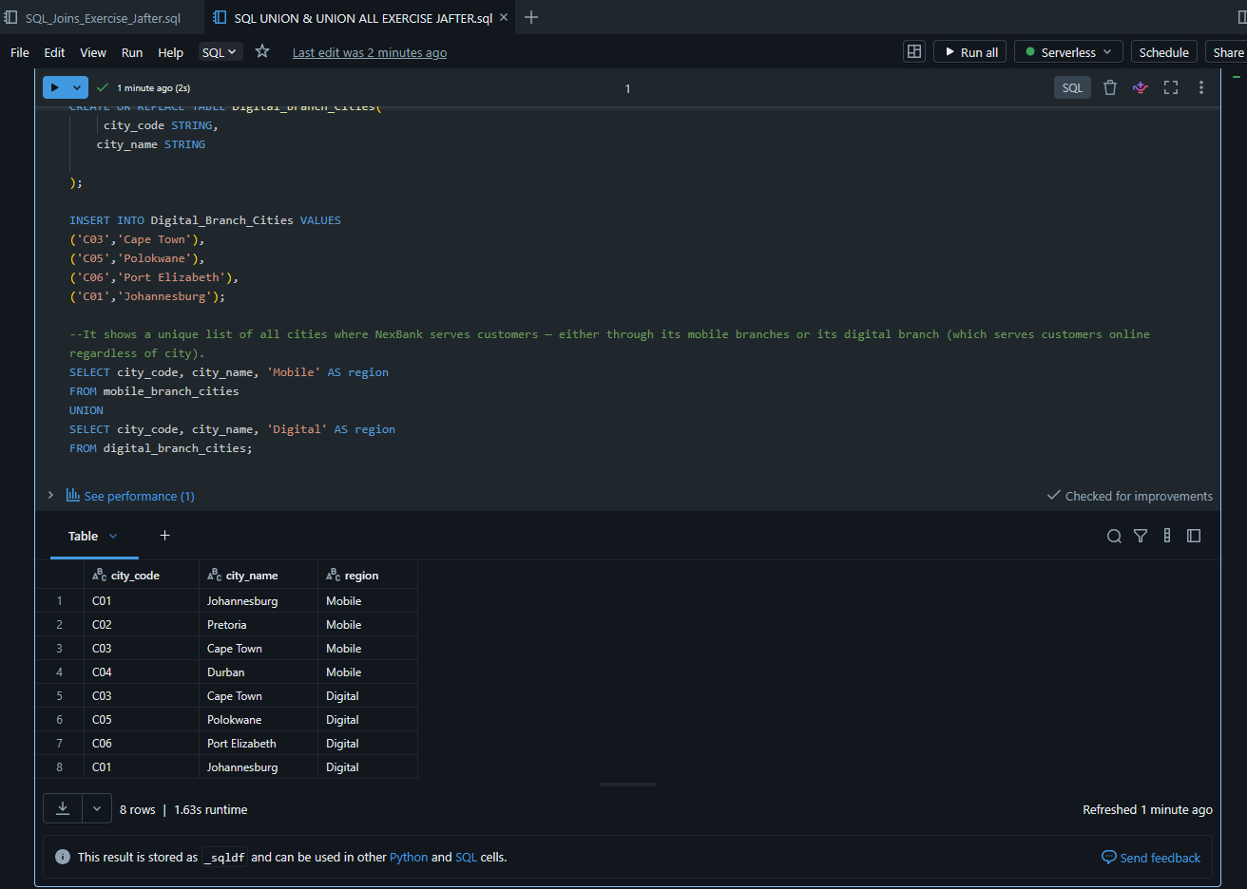

QUESTION 5:
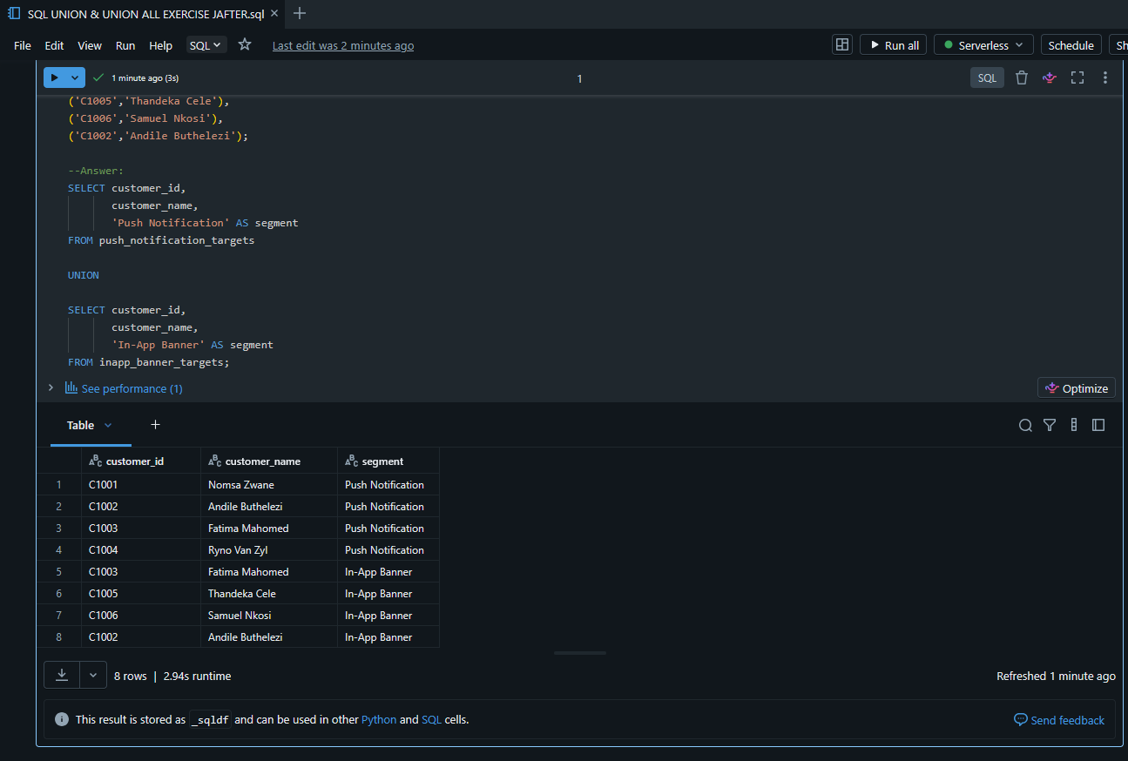

QUESTION 6:
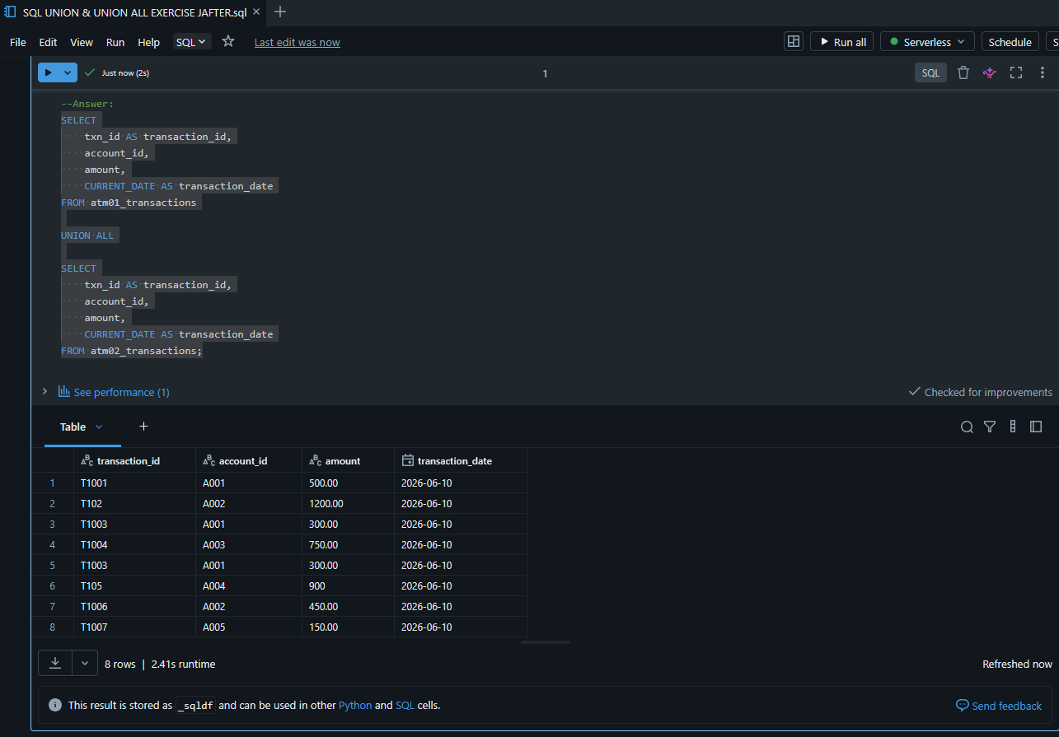

QUESTION 7:
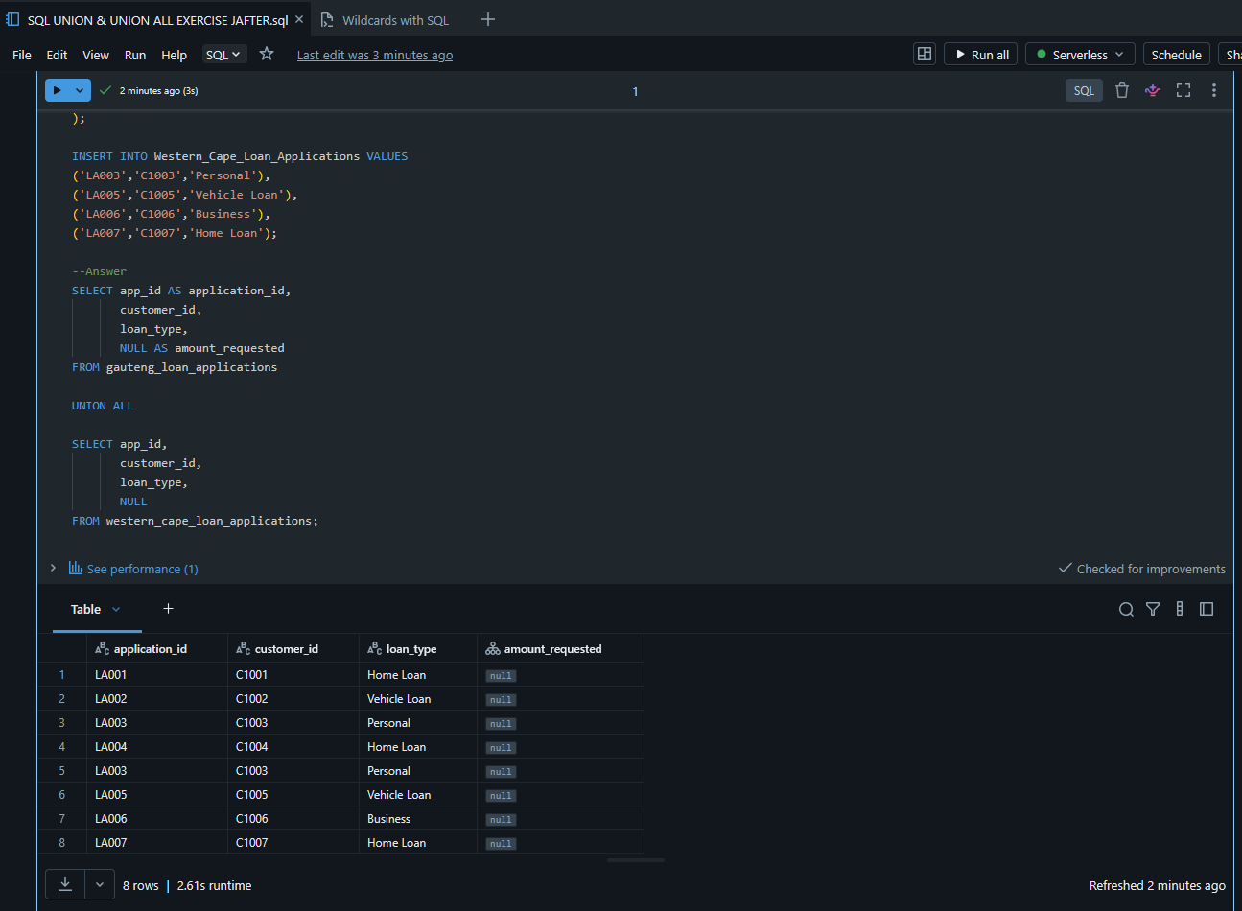

QUESTION 8:
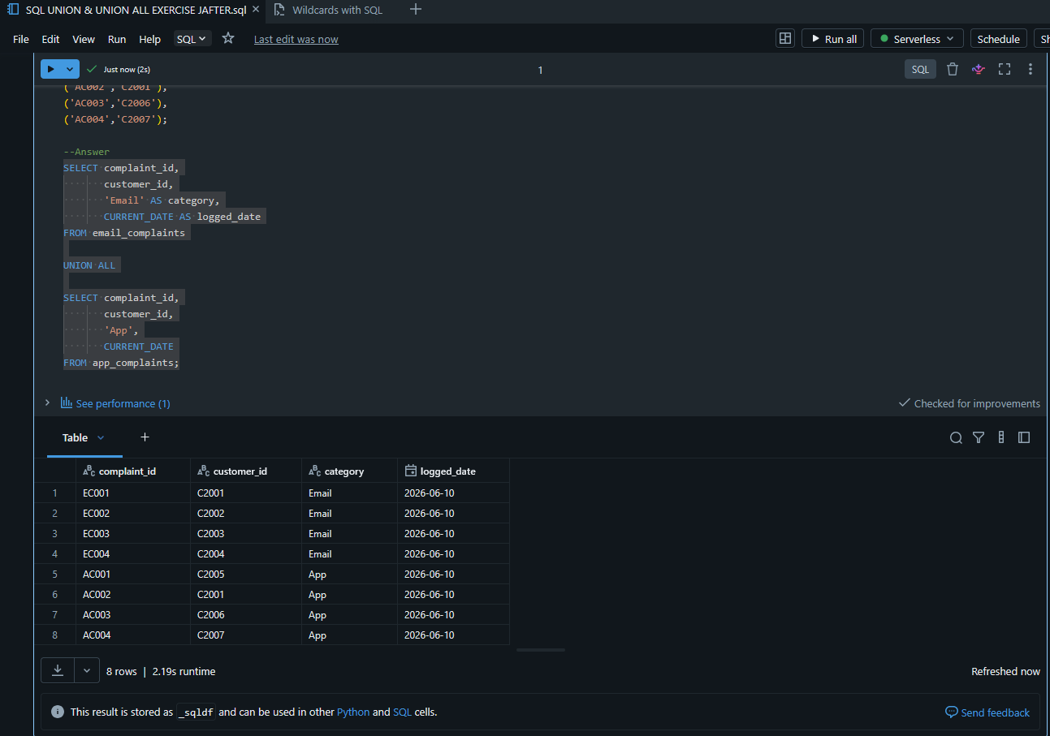

QUESTION 9:
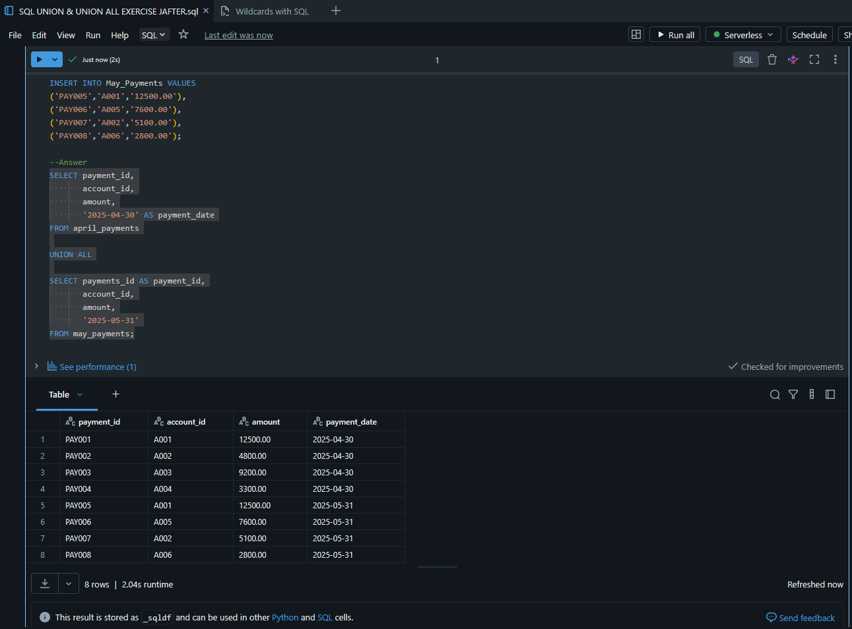

QUESTION 10:


Bonus Questions:
- They should use UNION, because the fraud analyst wants a unique list of customers from both watch lists. If a customer appears in both January and February, they should only appear once.
- They should also use UNION ALL, because the auditing team wants to count every transaction. Removing duplicates would reduce the count and produce incorrect audit results.
- The query fails because the first SELECT returns 2 columns while the second SELECT returns 3 columns. UNION requires both queries to return the same number of columns with compatible data types.

